
MATES Computer Science
Senior Capstone Project Bi-Weekly Progress Report
Project Title | Project Egress
Team Members | Ethan Todd, Liam Bragg, Madeline Rosshirt
Dates Covered by Report | 02/02/26 to 02/06/26; 02/09/26 to 02/13/26; 02/17/26 to 02/20/26; 02/25/26 to 02/27/26; 03/02/26
Link to Github | https://github.com/Fennec427/Project-Egress

Summary of Project (Provide a one paragraph summary of your project. You can largely copy/paste this from one progress report to the next, unless there are significant changes.)
Our project is called “Project Egress”. It is a 2-D puzzle platformer made in Unity with pixel art for graphics. Inspired by the video games Splatoon and Portal, the gameplay is centered around the use of different paint colors and their abilities across multiple levels of scaling difficulty. There will also be a variety of tools used to spread the paint. Levels will have stage elements such as spike traps or moving platforms to add a uniqueness to each level.

Summary of Progress this Period (Provide a high-level, one paragraph overview of what was accomplished this progress period collectively by the team.)

The early stages of February were primarily spent completing the posted assignments in the classroom that were meant to organize our thoughts and any advice given. Such assignments include a formal version of the “Project Proposal,” the “Project Scope,” and the “Project Pitch.” On top of this, we also made the Github repository for our project and made some notes we shared between our respective blocks. Mid to late February was primarily the learning/set-up stages of the project. We got our VMs up and running at the very least and began to install our software such as VS Code, Unity, and Git. Although they are not fully set up yet as we ran into some small VM issues and Unity issues, they should be done soon and time was not wasted waiting. While we started our set-up, we went through our list of things to learn by reviewing articles, videos, websites, and a “C#: Intro” Codecademy course. Overall, I have put a large dent in learning and shouldn’t have much left and we are trying to resolve a few set-up issues. After all that, we should begin.

Detailed Progress this Period, separated by Team Member (Provide detailed information on the progress that you made in the reporting weeks. Include screenshots of code, your game or website, etc. Each team member should have a separate subsection covering their accomplishments. Not including screenshots, this section should be 1-2 pages.)

Ethan: There were a lot of hiccups early on for me with trying to get the virtual machine to work and also setting up the software on the virtual machine itself. For the first couple of weeks, we took the assignments such as the “Project Proposal,” “Project Pitch,” and “Project Scope” and divided up the work accordingly as we progressed through. I made sure I did my share of the work with setting up and writing down the information for the slides in the “Project Pitch,” editing the “Project Proposal” and adding suggestions where needed, and adding information, framework, and some comments in the “Project Scope” assignment for Liam and Madeline to look over and edit in their block accordingly. Once all of the basic, starting assignments were done, we began with our project in terms of setting up and learning information. For me, I made sure to set up a notes document to help us communicate instructions and other information in between blocks so we know exactly what we need from each other. The first thing we did was set-up the virtual machine for each of us. As I started to review some articles we needed to go over to better understand parts of our project, Liam gave me the instructions to set up the virtual machine. It ended up taking me a day or two after that to fully set-up and update the virtual machine. After that, it also took me a few days to get the software set-up. Setting up VS Code and Git were easy, but I had some problems with the Unity installation that I couldn’t figure out. While this issue went on, I made sure I got back to reading more articles and watching videos to help learn more about our project while also mainly focusing on working on and completing the “Intro to C#” Codecademy course for the bulk of my time. By the time I read everything I needed to and completed the course, Liam gave me instructions on how to fix the Unity issues bugging us and I spent a day fixing that as well. Of course I spent time in between working on the little things like spending a day working on and fixing things in the Github repository, but other than that, that is what I have been focusing on.

Madeline: I helped write some of the “Project Proposal,” “Project Pitch,” and “Project Scope”. I helped tidy up the GitHub including a branch that I made to help move files into a folder (it worked so I added it to the main GitHub). In general for me the Virtual Machine worked fine. Took a day to set up then another 2-3 to get everything installed but Unity worked first try. I then went on to look at articles, videos, and started a codecademy course on C#. I messed around a bit with Unity as well trying to get familiar with the engine. I then went on to make and polish (to the best of my ability) a Trello page which ended quite well though I may need to move some tasks around to different stages of the project, it is a good starting point. Afterwards I went back and finished the codecademy course.

Liam: We all did our parts in making the project proposal, pitch, and scope. I read through the materials we thought were needed, and I already had previously done the C# Codecademy course. So, while my group members worked on that, I wrote quick and easy-ish install instructions for the virtual machines, to allow for the best possible speeds. My virtual machine was the one with the most problems, and it didn’t help that we missed time in class to fix it due to school closures from the snow. I had to reinstall windows on the virtual machine twice due to constant crashing and Unity Hub failing to open properly. Currently, I am working on getting the Unity project working on everyone’s computers. I set up a branch to test before merging with main.

Difficulties Encountered this Progress Period (Provide detailed information on the difficulties and issues that you encountered in the reporting weeks. Discuss mitigation strategies for how you got around or plan to get around these issues.)

Throughout the progress period, the main issue we had after the introductory first two weeks was setting up the software itself. Although getting the virtual machine was a bit difficult, we were able to get it set-up relatively quickly without any major issues. What was difficult was getting the software itself set-up. We needed to get VS Code, Git, and Unity Engine set-up on the virtual machine. Although VS Code and Git were easy, Unity Engine was annoying for Liam and Ethan. For Liam, Unity Hub was primarily difficult because it caused spontaneous crashing and just would not work properly. For Ethan, the download itself took a while and wouldn’t actually go through ever and only would partially install. Although these problems arose, we were able to get through them by spending a little bit of time trying to understand them and also by trying not to waste time on things we do not understand. Ethan was able to work on much more of the learning progress for C#, the language used in Unity, and other aspects of what we need to know, and Liam focused on trying to fix the crashing so he could attempt the Unity Engine installation. Once Liam got it installed, and both Madeline and Liam were good, Ethan attempted the installation again and it ended up working. The main way we were able to solve this problem was by being efficient and by not trying to brute force the problem. The only other difficulty we really encountered was the discordance caused by the weather and having extended periods of time off that really threw us off a little. We were able to get back on track, it just took us a little bit to get back into everything. Overall, we are good now and have a good foundation to work on in terms of problem solving.

Updated Trello Board and Discussion (Provide screenshot of and link to updated Trello board. Discuss any changes made to board since last progress report and why.)
https://trello.com/b/D29yQgac/project-egress
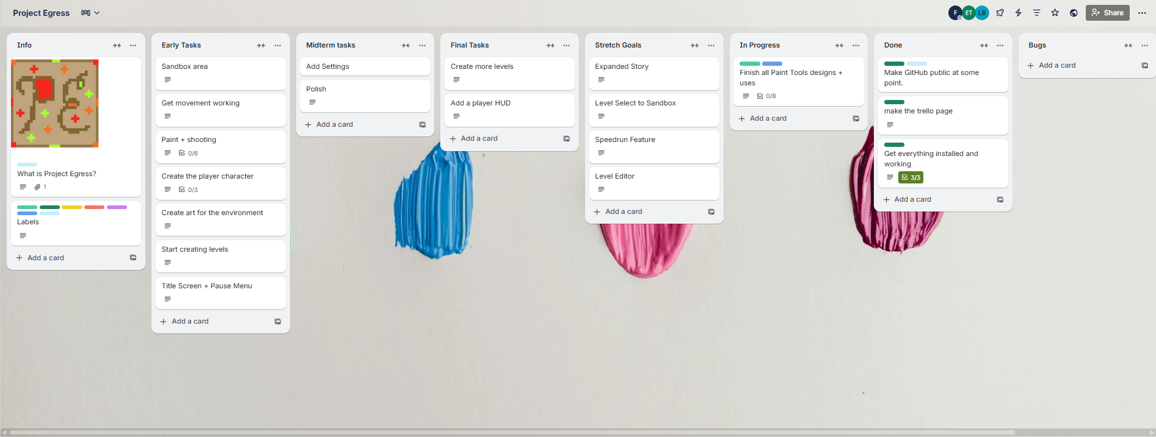
We made a Trello board.

Tasks to Be Worked on in Next Progress Period (Discuss the tasks to be worked on in the following two weeks. Discuss who is working on each.)
By the next progress period we will hopefully be able to create a small sandbox with placeholder assets and a placeholder character moving and possibly if we have time add a simple shooting script so we can easily work on the first tool. Ethan can start out with making some simple placeholders then slowly go into working on some scripting stuff. Liam will generally be focused on the scripting. Madeline will focus on trying to port the placeholder assets and making the small sandbox.

Additional Information (Provide any additional information that you want to provide in this section; for example, one of your teammates is going away next week, your Github account is gone, etc. It could be good news as well.)
Everyone has the needed programs working on their virtual machines!

